

**Data Dictionary**

Rockbuster Co.

By Elena Dries

November, 2022

Table of contents

Entity Relational Diagram (ERD) 2

Fact Table 3

**Rental** 3

Dimension Tables 4

**Payment** 4

**Store** 4

**Film Actor** 5

**Inventory** 5

**Film Category** 5

**Customer** 6

**Staff** 7

**Actor** 8

**Film** 8

**Category** 9

**Address** 10

**Language** 10

**City** 11

**Country** 11

# Entity Relational Diagram (ERD)

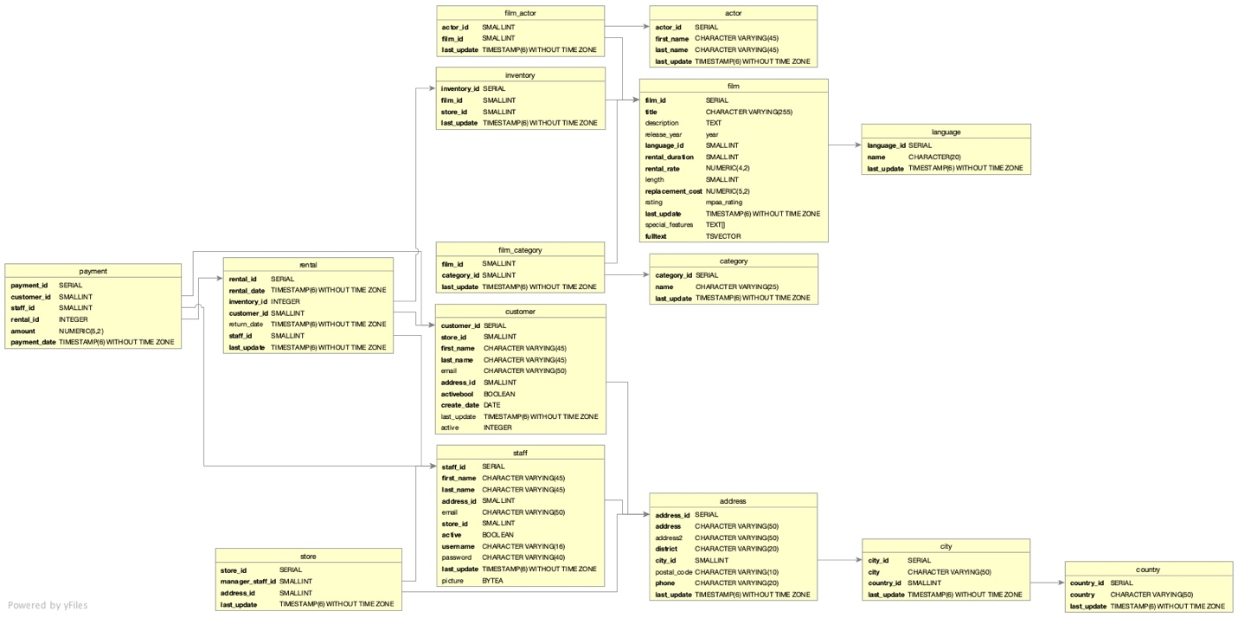

# Fact Table

Table Name:

## **Rental**

|  |  |  |  |  |
| --- | --- | --- | --- | --- |
| **Columns** | **Unique/**  **Foreign Key** | **Data Type** | **Description** | **Links To/From Table** |
| rental_id | Primary | SERIAL | ID of a rental transaction | From: Payment |
| rental_date |  | TIMESTAMP(6) WITHOUT TIME ZONE | Date when the rental took place |  |
| inventory_id | Foreign | INTEGER | ID of an item in the inventory | To: Inventory |
| customer_id | Foreign | SMALLINT | ID of a customer | To: Customer |
| return_date |  | TIMESTAMP(6) WITHOUT TIME ZONE | Date when return took place |  |
| staff_id | Foreign | SMALLINT | ID of a staff member | To: Staff |
| last_update |  | TIMESTAMP(6) WITHOUT TIME ZONE | Date when last update took place |  |

# Dimension Tables

Table Name:

## **Payment**

|  |  |  |  |  |
| --- | --- | --- | --- | --- |
| **Columns** | **Primary/**  **Foreign Key** | **Data Type** | **Description** | **Links To/From Table** |
| payment_id | Primary | SERIAL | ID of a payment transaction |  |
| customer_id | Foreign | SMALLINT | ID of a customer | To: Customer |
| staff_id | Foreign | SMALLINT | ID of a staff member | To: Staff |
| rental_id | Foreign | INTEGER | ID of a rental transaction | To: Rental |
| amount |  | NUMERIC(5,2) | The total amount of the transaction |  |
| payment_date |  | TIMESTAMP(6) WITHOUT TIME ZONE | Date when the payment took place |  |

Table Name:

## **Store**

|  |  |  |  |  |
| --- | --- | --- | --- | --- |
| **Columns** | **Primary/**  **Foreign Key** | **Data Type** | **Description** | **Links To/From Table** |
| store_id | Primary | SERIAL | ID of a store |  |
| manager_staff_id | Foreign | SMALLINT | ID of the responsible manager | To: Staff |
| address_id | Foreign | SMALLINT | ID of an address | To: Address |
| last_update |  | TIMESTAMP(6) WITHOUT TIME ZONE | Date when last update of the “Store” table took place |  |

Table Name:

## **Film Actor**

|  |  |  |  |  |
| --- | --- | --- | --- | --- |
| **Columns** | **Primary/**  **Foreign Key** | **Data Type** | **Description** | **Links To/From Table** |
| actor_id | Foreign | SMALLINT | ID of an actor | To: Actor |
| film_id | Foreign | SMALLINT | ID of a film | To: Film |
| last-update |  | TIMESTAMP(6) WITHOUT TIME ZONE | Date when last update of the “Film Actor” table took place |  |

Table Name:

## **Inventory**

|  |  |  |  |  |
| --- | --- | --- | --- | --- |
| **Columns** | **Primary/**  **Foreign Key** | **Data Type** | **Description** | **Links To/From Table** |
| inventory_id | Primary | SERIAL | ID of an item in the inventory | From: Rental |
| film_id | Foreign | SMALLINT | ID of a film | To: Film |
| store_id |  | SMALLINT | ID od a store |  |
| last_update |  | TIMESTAMP(6) WITHOUT TIME ZONE | Date when last update of the “Inventory” table took place |  |

Table Name:

## **Film Category**

|  |  |  |  |  |
| --- | --- | --- | --- | --- |
| **Columns** | **Primary/**  **Foreign Key** | **Data Type** | **Description** | **Links To/From Table** |
| film_id | Foreign | SMALLINT | ID of a film | To: Film |
| category_id | Foreign | SMALLINT | ID of a category | To: Category |
| last_update |  | TIMESTAMP(6) WITHOUT TIME ZONE | Date when last update of the “Film Category” table took place |  |

Table Name:

## **Customer**

|  |  |  |  |  |
| --- | --- | --- | --- | --- |
| **Columns** | **Primary/**  **Foreign Key** | **Data Type** | **Description** | **Links To/From Table** |
| customer_id | Primary | SERIAL | ID of a customer | From: Rental, Payment |
| store_id |  | SMALLINT | ID of a store |  |
| first_name |  | CHARACTER VARYING (45) | Customer first name |  |
| last_name |  | CHARACTER VARYING (45) | Customer last name |  |
| email |  | CHARACTER VARYING (50) | Customer e-mail address |  |
| address_id | Foreign | SMALLINT | ID of the customer address | To: Address |
| activebool |  | BOOLEAN | Customer status: active or not |  |
| create_date |  | DATE | Date of the entry creation |  |
| last-update |  | TIMESTAMP(6) WITHOUT TIME ZONE | Date when last update of the “Customer” table took place |  |
| active |  | INTEGER | Customer status |  |

Table Name:

## **Staff**

|  |  |  |  |  |
| --- | --- | --- | --- | --- |
| **Columns** | **Primary/**  **Foreign Key** | **Data Type** | **Description** | **Links To/From Table** |
| Staff_id | Primary | SERIAL | Staff member ID | From: Rental, Payment, Store |
| First-Name |  | CHARACTER VARYING (45) | Staff member first name |  |
| Last_name |  | CHARACTER VARYING (45) | Staff member last name |  |
| Address_id | Foreign | SMALLINT | Address ID | To: Address |
| Email |  | CHARACTER VARYING (50) | Staff member e-mail address |  |
| Store_id |  | SMALLINT | ID of a store |  |
| Active |  | BOOLEAN | Staff member status: active or not |  |
| Username |  | CHARACTER VARYING (16) | Staff member user name |  |
| Password |  | CHARACTER VARYING (40) | Password of a staff member |  |
| Last-update |  | TIMESTAMP(6) WITHOUT TIME ZONE | Date when last update of the “Staff” table took place |  |
| picture |  | BYTEA | Picture of a staff member |  |

Table Name:

## **Actor**

|  |  |  |  |  |
| --- | --- | --- | --- | --- |
| **Columns** | **Primary/**  **Foreign Key** | **Data Type** | **Description** | **Links To/From Table** |
| actor_id | Primary | SERIAL | ID of an actor | From: Film Actor |
| first_name |  | CHARACTER VARYING (45) | Actor first name |  |
| last_name |  | CHARACTER VARYING (45) | Actor last name |  |
| last_update |  | TIMESTAMP(6) WITHOUT TIME ZONE | Date when last update of the “Actor” table took place |  |

Table Name:

## **Film**

|  |  |  |  |  |
| --- | --- | --- | --- | --- |
| **Columns** | **Primary/**  **Foreign Key** | **Data Type** | **Description** | **Links To/From Table** |
| film_id | Primary | SERIAL | ID of a film | From: Film Actor, Inventory, Film Category |
| title |  | CHARACTER VERYING(255) | Film title |  |
| description |  | TEXT | Film description |  |
| release_year |  | year | The year when the film was released |  |
| language_id | Foreign | SMALLINT | ID of the film language | To: Language |
| rental_duration |  | SMALLINT | Number of days the film is rented for |  |
| rental_rate |  | NUMERIC(4,2) | Rate at which the film is rented |  |
| length |  | SMALLINT | Length of the film in minutes |  |
| replacement_cost |  | NUMERIC(5,2) | The cost of the film replacement |  |
| rating |  | mpaa_rating | Motion Picture Association rating |  |
| last_update |  | TIMESTAMP(6) WITHOUT TIME ZONE | Date when last update of the “Film” table took place |  |
| Special_features |  | TEXT[] | List of special features |  |
| fulltext |  | TSVECTOR | Key words |  |

Table Name:

## **Category**

|  |  |  |  |  |
| --- | --- | --- | --- | --- |
| **Columns** | **Primary/**  **Foreign Key** | **Data Type** | **Description** | **Links To/From Table** |
| category_id | Primary | SERIAL | ID of a category | From: Film Category |
| name |  | CHARACTER VERYING(25) | Category name |  |
| last_update |  | TIMESTAMP(6) WITHOUT TIME ZONE | Date when last update of the “Category” table took place |  |

Table Name:

## **Address**

|  |  |  |  |  |
| --- | --- | --- | --- | --- |
| **Columns** | **Primary/**  **Foreign Key** | **Data Type** | **Description** | **Links To/From Table** |
| address_id | Primary | SERIAL | ID of an address | From: Customer, Staff, Store |
| address |  | CHARACTER VERYING(50) | Postal address |  |
| address2 |  | CHARACTER VERYING(50) | Another postal address |  |
| district |  | CHARACTER VERYING(20) | Name of a district |  |
| city_id | Foreign | SMALLINT | ID of a city | To: City |
| postal_code |  | CHARACTER VERYING(10) | Postal code |  |
| phone |  | CHARACTER VERYING(20) | Phone number |  |
| last_update |  | TIMESTAMP(6) WITHOUT TIME ZONE | Date when last update of the “Address” table took place |  |

Table Name:

## **Language**

|  |  |  |  |  |
| --- | --- | --- | --- | --- |
| **Columns** | **Primary/**  **Foreign Key** | **Data Type** | **Description** | **Links To/From Table** |
| language_id | Primary | SERIAL | ID of a language | From: Film |
| name |  | CHARACTER VERYING(20) | Name of a language |  |
| last_update |  | TIMESTAMP(6) WITHOUT TIME ZONE | Date when last update of the “Language” table took place |  |

Table Name:

## **City**

|  |  |  |  |  |
| --- | --- | --- | --- | --- |
| **Columns** | **Primary/**  **Foreign Key** | **Data Type** | **Description** | **Links To/From Table** |
| city_id | Primary | SERIAL | ID of a city | From: Address |
| city |  | CHARACTER VERYING(50) | Name of a city |  |
| country_id | Foreign | SMALLINT | ID of a country | To: Country |
| last_update |  | TIMESTAMP(6) WITHOUT TIME ZONE | Date when last update of the “City” table took place |  |

Table Name:

## **Country**

|  |  |  |  |  |
| --- | --- | --- | --- | --- |
| **Columns** | **Primary/**  **Foreign Key** | **Data Type** | **Description** | **Links To/From Table** |
| country_id | Primary | SERIAL | ID of a country | From: City |
| country |  | CHARACTER VERYING(50) | Country name |  |
| last_update |  | TIMESTAMP(6) WITHOUT TIME ZONE | Date when last update of the “Country” table took place |  |